<https://www.youtube.com/watch?v=yIr_1CasXkM>

**Aprende React ahora! curso completo para crear aplicaciones abril 2024**

-- Introducción -- [00:00:00](https://www.youtube.com/watch?v=yIr_1CasXkM&t=0s) Por qué aprender React? [00:00:33](https://www.youtube.com/watch?v=yIr_1CasXkM&t=33s) Temario [00:01:55](https://www.youtube.com/watch?v=yIr_1CasXkM&t=115s) Requisitos [00:04:14](https://www.youtube.com/watch?v=yIr_1CasXkM&t=254s) Qué es React? [00:09:56](https://www.youtube.com/watch?v=yIr_1CasXkM&t=596s) Configurando ambiente de trabajo [00:13:26](https://www.youtube.com/watch?v=yIr_1CasXkM&t=806s) Creando una app [00:17:49](https://www.youtube.com/watch?v=yIr_1CasXkM&t=1069s) Estructura del proyecto [00:21:45](https://www.youtube.com/watch?v=yIr_1CasXkM&t=1305s) Componentes en React [00:29:08](https://www.youtube.com/watch?v=yIr_1CasXkM&t=1748s) Como funciona? -- Componentes -- [00:33:19](https://www.youtube.com/watch?v=yIr_1CasXkM&t=1999s) Introducción [00:34:03](https://www.youtube.com/watch?v=yIr_1CasXkM&t=2043s) Bootstrap [00:37:24](https://www.youtube.com/watch?v=yIr_1CasXkM&t=2244s) Componente Card [00:43:54](https://www.youtube.com/watch?v=yIr_1CasXkM&t=2634s) Fragments [00:47:39](https://www.youtube.com/watch?v=yIr_1CasXkM&t=2859s) Pasando props [00:52:57](https://www.youtube.com/watch?v=yIr_1CasXkM&t=3177s) Múltiples props [00:56:40](https://www.youtube.com/watch?v=yIr_1CasXkM&t=3400s) Children [01:00:08](https://www.youtube.com/watch?v=yIr_1CasXkM&t=3608s) Imprimir listas [01:07:14](https://www.youtube.com/watch?v=yIr_1CasXkM&t=4034s) Gestión de eventos [01:14:10](https://www.youtube.com/watch?v=yIr_1CasXkM&t=4450s) Gestión de estado [01:22:13](https://www.youtube.com/watch?v=yIr_1CasXkM&t=4933s) Funciones como props [01:27:51](https://www.youtube.com/watch?v=yIr_1CasXkM&t=5271s) State VS Props [01:29:52](https://www.youtube.com/watch?v=yIr_1CasXkM&t=5392s) Truthy y falsy en React [01:34:14](https://www.youtube.com/watch?v=yIr_1CasXkM&t=5654s) Renderizado condicional [01:39:03](https://www.youtube.com/watch?v=yIr_1CasXkM&t=5943s) React Developer Tools [01:42:25](https://www.youtube.com/watch?v=yIr_1CasXkM&t=6145s) Ejercicio - botón de carga [01:51:12](https://www.youtube.com/watch?v=yIr_1CasXkM&t=6672s) Ejercicio - Gestor de minions -- Estilos -- [01:57:18](https://www.youtube.com/watch?v=yIr_1CasXkM&t=7038s) Introducción [01:57:58](https://www.youtube.com/watch?v=yIr_1CasXkM&t=7078s) Inline Style [02:00:28](https://www.youtube.com/watch?v=yIr_1CasXkM&t=7228s) Estructura de directorios [02:03:27](https://www.youtube.com/watch?v=yIr_1CasXkM&t=7407s) CSS [02:06:29](https://www.youtube.com/watch?v=yIr_1CasXkM&t=7589s) Módulos de CSS [02:12:59](https://www.youtube.com/watch?v=yIr_1CasXkM&t=7979s) CSS en JavaScript [02:22:16](https://www.youtube.com/watch?v=yIr_1CasXkM&t=8536s) Bibliotecas populares [02:31:31](https://www.youtube.com/watch?v=yIr_1CasXkM&t=9091s) Agradecimientos y como seguir

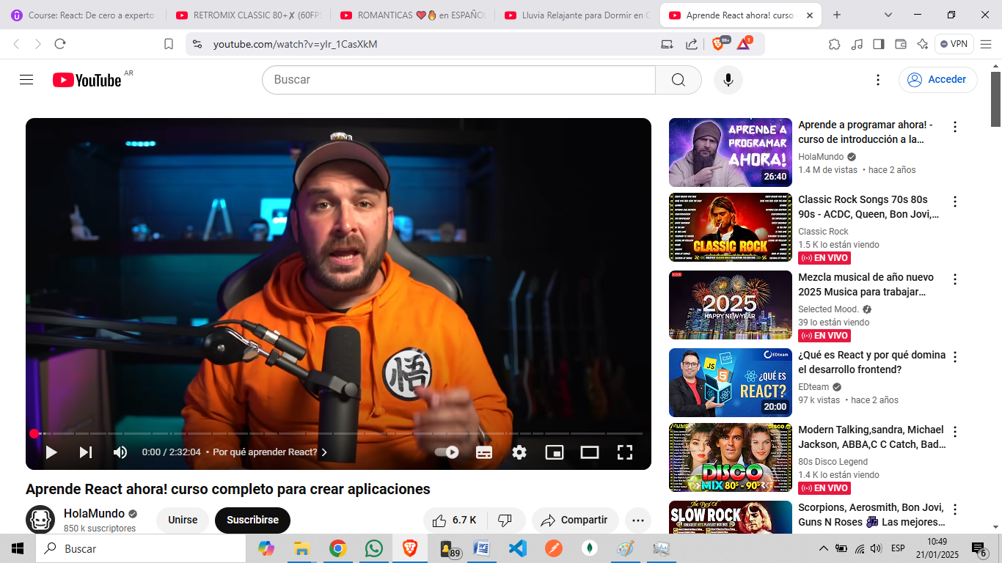

<https://www.youtube.com/watch?v=0C5yFwOYhAk>

**Aprende REACT con 3 proyectos incluidos! +6 horas 2023 (**[**https://www.youtube.com/@Codigo369**](https://www.youtube.com/@Codigo369)**)**

7 horas

